___________________________________________________________________

Software Requirements Specification
for
Realtime Chat Application
Version 1.0 approved
Prepared by Adityan Verma
Delhi Technical Campus, Greater Noida
November 14, 2023
___________________________________________________________________

Copyright © 2023 by Adityan Verma Permission is granted to use, and distribute this document
- INTRODUCTION
  - PURPOSE
This Software Requirements Specification (SRS), version 1.0, delineates the essential features and functionalities for a Real-time chat application Project. It comprehensively covers critical elements such as user authentication to ensure secure access, real-time messaging capabilities, support for multimedia content sharing, and a scalable architecture capable of accommodating a substantial user base.

Additionally, this SRS emphasizes the importance of user privacy and system security through stringent protocols like end-to-end encryption and robust data protection measures.

While focusing on the core aspects of the chat application, this document sets the stage for future iterations and potential expansions, ensuring a solid foundation upon which enhancements and additional features can integrated smoothly.

Its primary objective is to serve as a definitive guide for stakeholders, providing a clear roadmap for developers and designers, and ensuring alignment with user needs, technological standards, and business objectives. This document aims to facilitate the development of a user-friendly, secure, and adaptable Real-time chat application.

  - INTENDED AUDIENCE AND READING SUGGESTIONS
Audience: This Software Requirements Specification (SRS) is designed to cater to various stakeholders involved in the development and implementation of the Real-time chat application. The intended audience includes:
- Developers: Responsible for implementing the technical aspects outlined in the document.
- Project Managers: Overseeing the project's progress, ensuring adherence to requirements, timelines, and resources.
- Designers: Involved in creating the user interface and overall user experience.
- Testers: Responsible for validating and verifying the application against specified requirements.
- Documentation Writers: Involved in creating user manuals, technical documentation, and guides.
- Marketing Staff: Gaining an understanding of the application's features and capabilities for promotional purposes.
- Users (End-Users): Understanding the functionalities and capabilities of the chat application.
Document Overview: The SRS contains a detailed description of the functional and non-functional requirements of the Real-time chat application. It includes sections outlining user interactions, system interfaces, performance expectations, security measures, and scalability needs.

Organization of the Document: The SRS is organized into distinct sections that cover specific aspects of the application. It begins with an overview, followed by sections detailing user requirements, system architecture, security considerations, and performance benchmarks. The document culminates in a conclusion summarizing the key points and outlining future considerations.

Reading Sequence: For an efficient understanding of the document, readers are suggested to follow this sequence:
- Overview Sections: Start with the executive summary and introduction to grasp the high-level goals and functionalities of the chat application. This section is beneficial for all reader types.
- User-Centric Sections: Developers, designers, and testers should focus on sections outlining user requirements, interface specifications, and usability considerations.
- Technical Sections: Developers and technical staff should delve into system architecture, security protocols, scalability details, and performance benchmarks.
- Management and Documentation Sections: Project managers, documentation writers, and marketing staff can focus on sections outlining project milestones, documentation requirements, and marketing insights.

This structured sequence enables each reader to delve into sections that are most relevant to their roles, ensuring a comprehensive understanding of the Real-time chat application's requirements and functionalities.

  - PRODUCT SCOPE
Description: The Real-time Chat Application is a communication platform designed to facilitate instant messaging, multimedia sharing, and real-time interactions between users. Its primary purpose is to offer a seamless and secure communication experience across various devices and platforms. The key objectives include enabling instantaneous messaging, supporting multimedia file sharing, ensuring user privacy and data security, and fostering user engagement through intuitive features.

Benefits and Objectives:

- Enhanced Communication: Enable users to exchange messages and multimedia content swiftly.
- Improved User Experience: Foster user engagement through an intuitive and user-friendly interface.
- Data Security: Prioritize user privacy through robust encryption and security measures.
- Scalability: Allow seamless expansion to accommodate a growing user base.

Alignment with Business Strategies: The Real-time Chat Application aligns with broader business strategies by:

- Enhancing Communication: Contributing to improved internal and external communication, fostering collaboration.
- Strengthening Engagement: Facilitating user interaction, thereby enhancing brand engagement and customer satisfaction.
- Meeting Technological Demands: Addressing the need for advanced communication tools in a tech-driven environment.

- OVERALL DESCRIPTION
  - PRODUCT PERSPECTIVE
User Profiles:
- User Information: Each user profile includes essential details such as username, email, and profile picture.
- Contact List: Allows users to create and manage their contact list for streamlined communication.

Messaging Features:
- Instant Messaging: Enables real-time text-based communication between users.
- Multimedia Sharing: Users can share images, videos, and files during conversations.

Security Measures:
- End-to-End Encryption: Ensures the confidentiality of messages transmitted between users.
- User Authentication: Provides secure access and protects user accounts from unauthorized access.

Functionalities:
- Real-time Notifications: Notifies users of new messages or updates instantly.
- Status Indicators: Displays the online/offline status of contacts for easy interaction.

System Architecture:
- Centralized Server: Utilizes a central server for efficient message routing and data storage.
- Cross-Platform Compatibility: Supports usage across multiple devices, ensuring accessibility on various platforms.

Data Model:
- Message Records: Stores conversation histories and maintains message logs securely.
- User Preferences: Saves individual settings and customization choices for a personalized experience.

  - PRODUCT PERSPECTIVE
The major features of the real-time chat application database system as shown in below
entity–relationship model (ER model): -

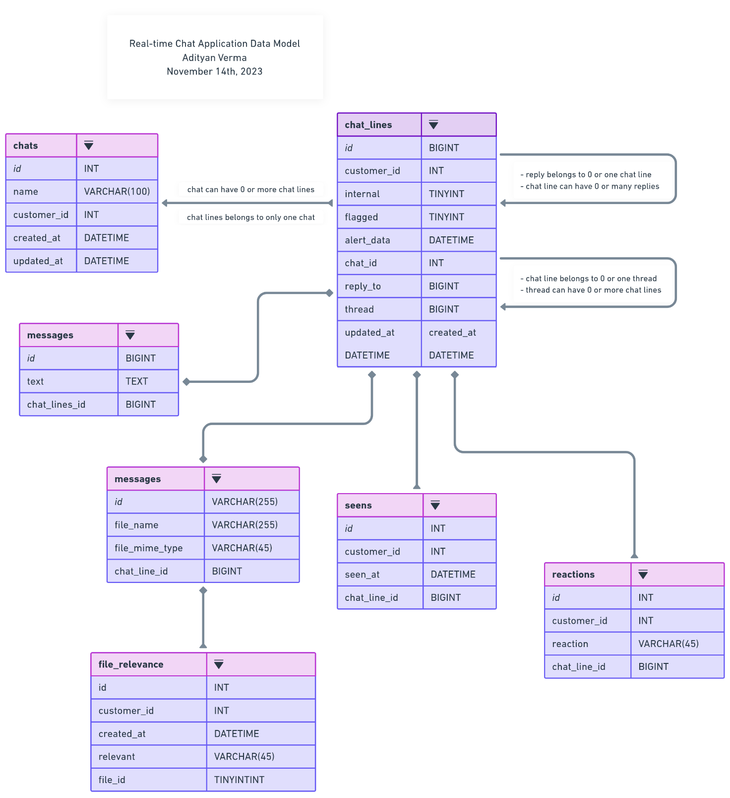
The diagram shows the layout of chat application database system – entity–relationship model

  - USER CLASSES AND CHARACTERISTICS
  - OPERATING ENVIORNMENT
  - DESIGN AND IMPLEMENTATION CONSTRAINTS
  - ASSUMPTIONS AND DEPENDENCIES

